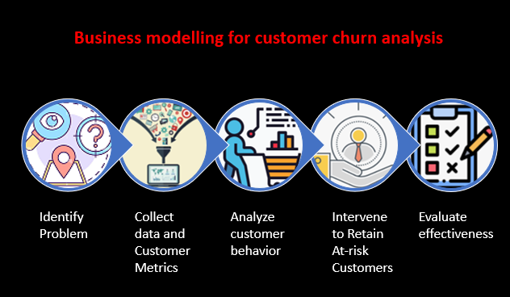**Business Model**

1. **Identify the problem:** The first step is to identify the problem that the business wants to solve. In this case, the problem is customer churn, or the rate at which customers stop doing business with the company.
2. **Data collection**: The next step is to collect data on customer behavior. This data may include purchase history, customer demographics, and other relevant information.
3. **Analysis:** Once the data has been collected, it is analyzed to identify trends and patterns. The analysis may involve the use of machine learning algorithms or other statistical techniques to predict which customers are at risk of churning.
4. **Intervention**: Based on the analysis, the company can implement interventions to reduce churn. This may include personalized marketing campaigns, loyalty programs, or other incentives to retain customers.
5. **Evaluation:** Finally, the effectiveness of the interventions should be evaluated using metrics such as customer retention rates, customer satisfaction scores, and other relevant measures.

**Implementing the Subscription Based model based on the following steps:**

1. **Identify the problem:** The problem is that customers are churning out of the subscription-based model. In this case, churn is defined as the percentage of customers who cancel their subscription during a given period.
2. **Data collection:** Subscription-based businesses typically have access to a wealth of customer data, such as purchase history, subscription length, renewal dates, and other relevant information. This data can be collected and analyzed to identify patterns in customer behavior.
3. **Analysis**: Using the collected data, businesses can analyze customer behavior to identify trends and patterns that indicate a risk of churn. For example, customers who have been subscribed for a long time but have not made a purchase in the last few months may be at risk of churning.
4. **Intervention:** Once at-risk customers have been identified, businesses can implement interventions to retain them. These may include targeted marketing campaigns, loyalty programs, or personalized offers to incentivize customers to stay subscribed.
5. **Evaluation**: Finally, the effectiveness of the interventions can be evaluated using metrics such as customer retention rates and revenue generated by retained customers.

By following these steps, businesses can improve their customer retention rates and maximize revenue from subscription-based models. This can be monetized by charging a subscription fee or taking a commission on customer transactions.

It's important to note that the specific interventions will depend on the nature of the subscription-based business, the target customer demographic, and the available data. A successful subscription-based business model requires continuous monitoring and adjustment to ensure maximum customer retention and revenue generation.

**Implementing the Pay-Per-Use model based on the following steps:**

1. **Identify the problem**: The problem is that customers are churning out of the pay-per-use model. In this case, churn is defined as the percentage of customers who stop using the product or service during a given period.
2. **Data collection:** Pay-per-use businesses typically have access to a wealth of usage data, such as the number of times a product or service is used, the duration of usage, and other relevant information. This data can be collected and analyzed to identify patterns in customer behavior.
3. **Analysis:** Using the collected data, businesses can analyze customer behavior to identify trends and patterns that indicate a risk of churn. For example, customers who have not used the product or service in the last few weeks may be at risk of churning.
4. **Intervention:** Once at-risk customers have been identified, businesses can implement interventions to retain them. These may include personalized offers, promotional discounts, or improved customer service to encourage customers to continue using the product or service.
5. **Evaluation:** Finally, the effectiveness of the interventions can be evaluated using metrics such as customer retention rates and revenue generated by retained customers.

By following these steps, businesses can improve their customer retention rates and maximize revenue from pay-per-use models. This can be monetized by charging a fee for each usage or taking a commission on customer transactions.

It's important to note that the specific interventions will depend on the nature of the pay-per-use business, the target customer demographic, and the available data. A successful pay-per-use business model requires continuous monitoring and adjustment to ensure maximum customer retention and revenue generation.